**File Creation**

1.Create a directory called ""my_folder"", navigate into it, and create a file named ""my_file.txt"" with some text. Then, create another file named ""another_file.txt"" with some text. Concatenate the content of ""another_file.txt"" to ""my_file.txt"" and display the updated content. Finally, list all files and directories in the current directory.

* Create Directory

**mkdir my_folder**

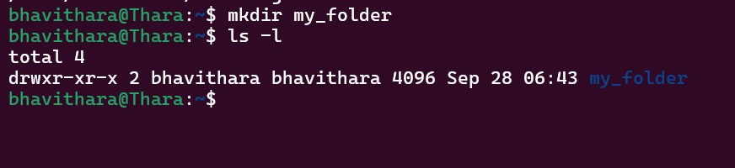

* create a file named ""my_file.txt"" with some text.

**cat > my_file.txt –** This will allows us to create the file and add the content as well

Give this command and then type you content. Once the content is added press

**Ctrl + D** to save the file.

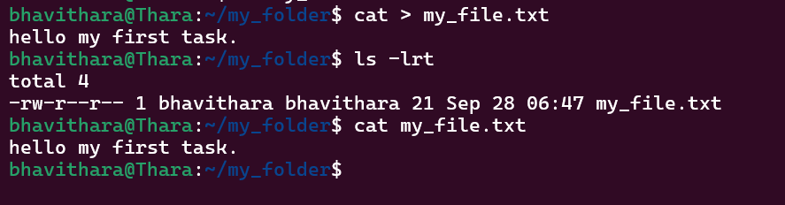

* create another file named ""another_file.txt"" with some text



* Concatenate the content of ""another_file.txt"" to ""my_file.txt"" and display the updated content.

**cat another_file.txt >> my_file.txt**  - To concatenate the content

**cat my_file.txt** – To display the content

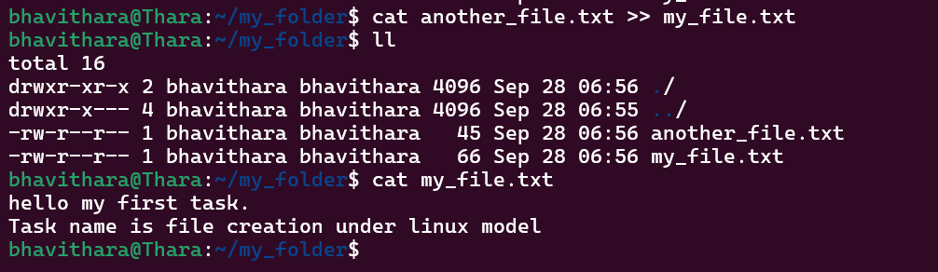

Other commands to concatenate:

* cat f1 f2 – display the contents of the two files together
* cat f1 f2 > f3 – This will concatenate and save the content to a new file.
* Finally, list all files and directories in the current directory.

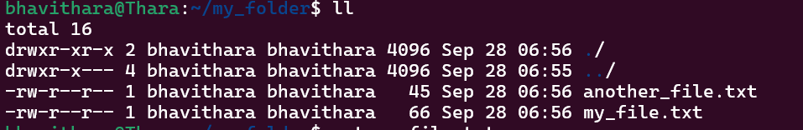

2. Create 20 files with .txt extensions and rename the first 5 files to .yml extension and Print the latest created top 5 files among the total no of files".

* Create 20 files with .txt extensions

**touch file_{1,2,3,4,5,6,7,8,9,10,11,12,13,14,15,16,17,18,19,20}.txt**

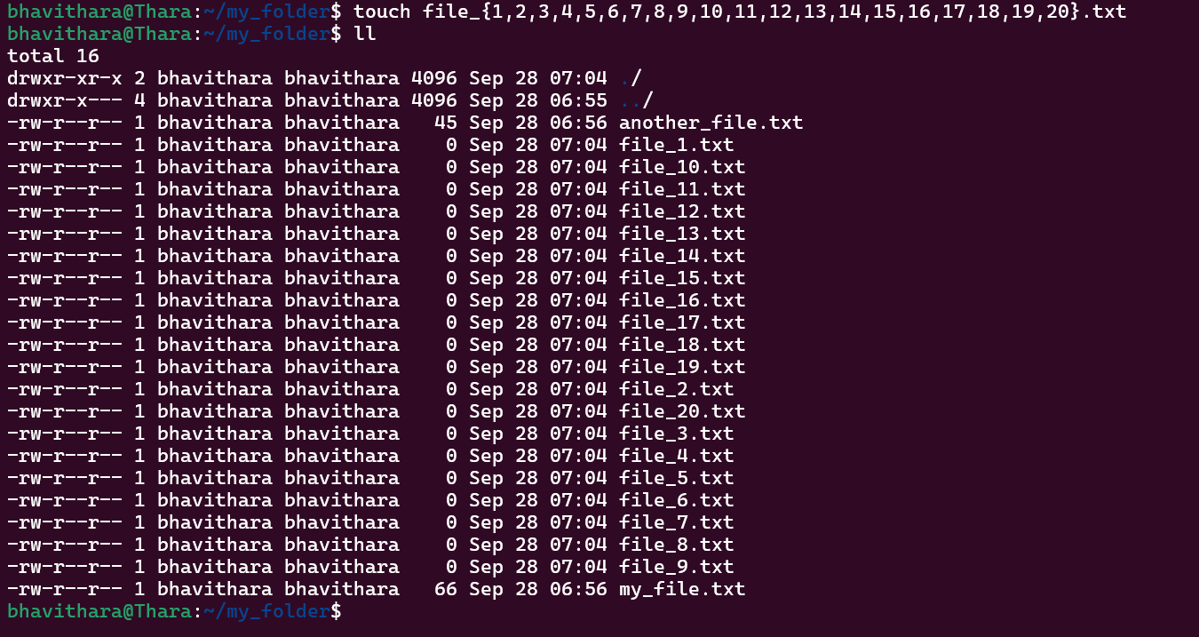

* Other commands to create multiple files:
  + - touch f1 f2 f3 f4 f5
    - for i in {1 ..5}; do

touch myfile_$i.txt

done

* + - for i in $(seq 6 10); do

touch seqfile_$i.txt

done

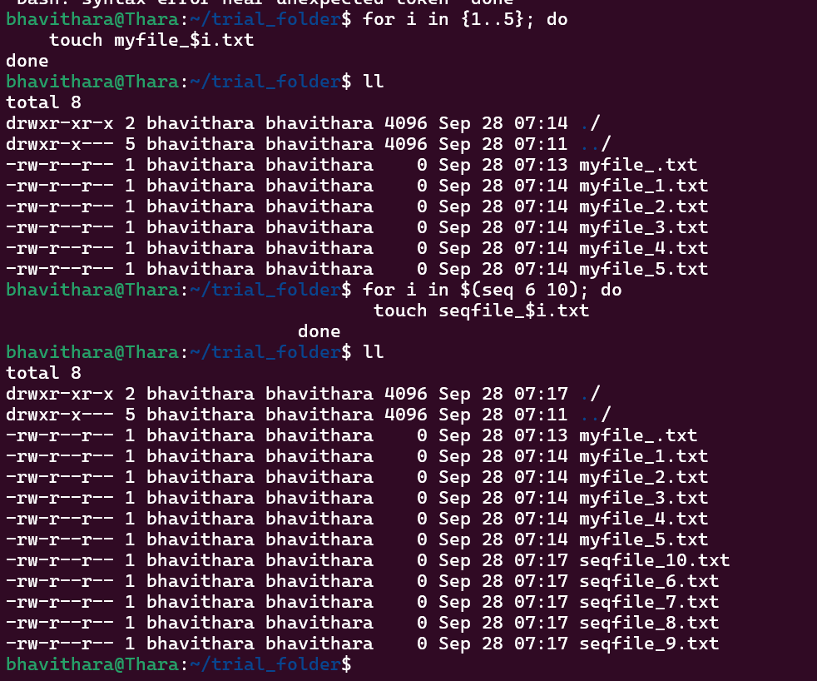

* Rename the first 5 files to .yml extension and Print the latest created top 5 files among the total no of files

**rename 's/\.txt$/.yml/' $(ls *.txt | head -n 5)** - Rename the file extension.

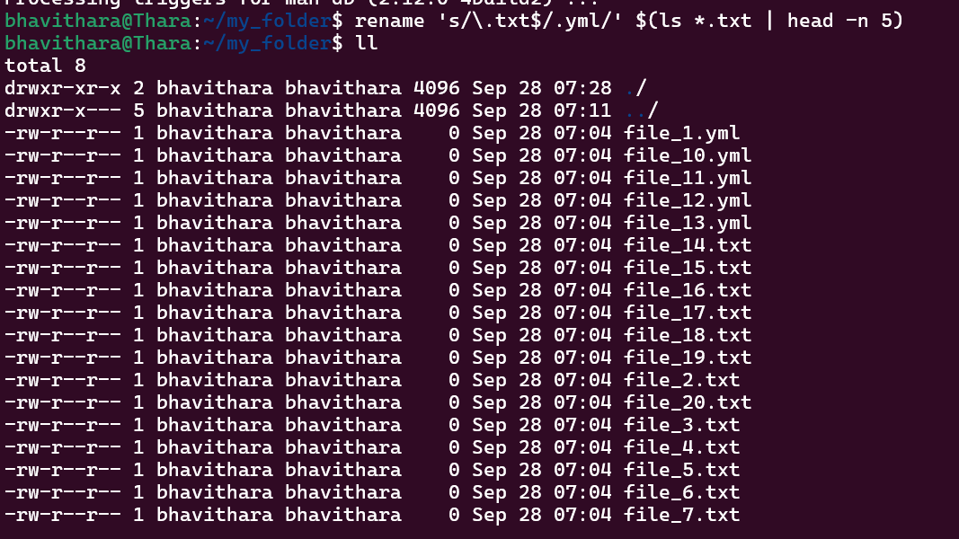

**ls -t | head -n 5 -** To print

